Lab program Number: 10 Date: 2082-05-01

Title: Implementation of Dynamic Interior/ Exterior Routing (RIP, OSPF, BGP)

**Theory:**

**Dynamic Interior Routing/ Exterior Routing**

Dynamic Interior Routing automatically manages and updates routes *within* a single Autonomous System (AS). It helps routers in the same organization share routing information and choose the best path to destinations. Common protocols include RIP, OSPF, and EIGRP.

Dynamic Exterior Routing handles routing between different Autonomous Systems (ASes), enabling communication across multiple networks or organizations. The main protocol used is BGP (Border Gateway Protocol), which ensures efficient and reliable data transfer across the Internet.

**RIP, OSPF, BGP**

**RIP:** A simple distance-vector protocol that selects routes based on hop count (maximum 15). It’s easy to configure but has slow convergence and limited scalability.

**OSPF:** A link-state protocol using Dijkstra’s algorithm to find the shortest path. It supports large networks with fast convergence, hierarchical areas, and VLSM, though setup is more complex.

**BGP:** A path-vector protocol used for routing between ASes. It supports policy-based routing and is highly scalable, but slower and more complex to configure than internal protocols.

**Network Diagram**

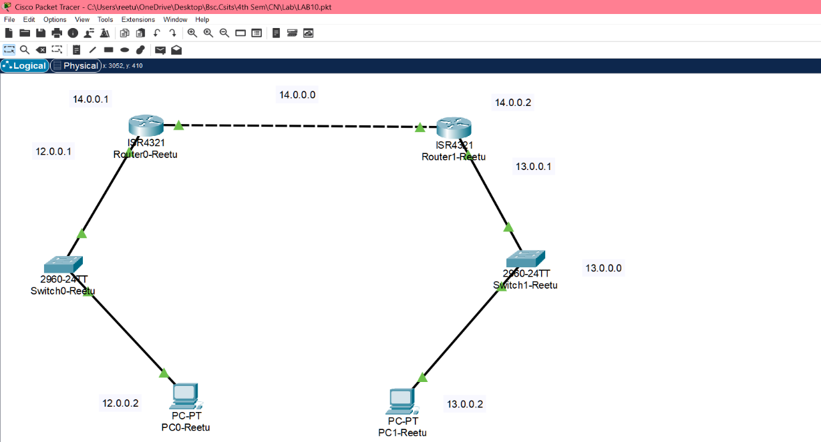

Fig: Network Diagram

**Implementation Sequence**

Here is the implementation sequence for Implementation of Dynamic Interior/ Exterior Routing (RIP, OSPF, BGP).

**Configuring Network**

**Configure the network for PCs and Routers**

**Step 1: Open Packet Tracer and set up the devices.**

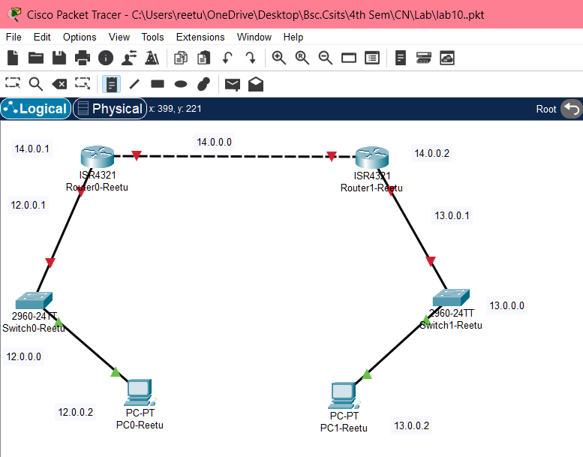

Fig: Simple Network setup

**Step 2: Assign IP addresses to each PC.**

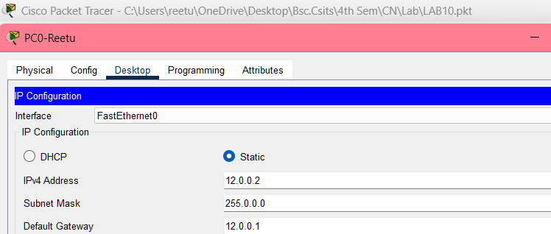

Fig: IP configuration

**Step 3: Assign IP addresses to router interfaces.**

Fig: Gigabit Ethernet configuration on router0

Fig: Gigabit Ethernet configuration on router1

**Implementation & explain the need for Dynamic Routing**

**Implementation of Dynamic Routing:** Dynamic routing protocols, such as RIP, OSPF, and BGP, are used to enable routers to automatically exchange and update routing information based on changes in the network. The implementation process involves:

**Network Configuration:** Set up our network by configuring routers and PCs and assign IP addresses to each device.

**Dynamic Routing Setup:** Enable the chosen dynamic routing protocol (RIP, OSPF, or BGP) on each router. This allows routers to automatically share and update routing information.

**Testing:** Use tools like ping to verify that the network configuration is correct and that connectivity is established across the routers.

**Need for Dynamic Routing:** Dynamic routing is crucial for modern networks due to the following reasons:

* **Automatic Route Updates:** As network conditions change-such as when links fail or new devices are added-dynamic routing protocols automatically update the routing tables. This keeps the network connected without requiring manual adjustments.
* **Scalability:** In large or rapidly changing networks, manually configuring static routes can be impractical. Dynamic routing protocols handle the growth of the network efficiently, making it easier to scale.
* **Efficient Path Selectin:** Dynamic protocols continuously evaluate network conditions and choose the best path for data. This helps in optimizing performance and reducing delays.
* **Redundancy and Fault Tolerance:** These protocols improve network reliability by quickly adapting to failures and rerouting traffic through alternative paths, minimizing downtime.
* **Improve Load Balancing:** Dynamic routing protocols can distribute network traffic evenly across multiple paths. This load balancing ensures that no single path is overloaded, enhancing overall network efficiency overall network efficiency and performance.

**Dynamic Routing Configuration**

**Using RIP Command**

**Network Diagram**

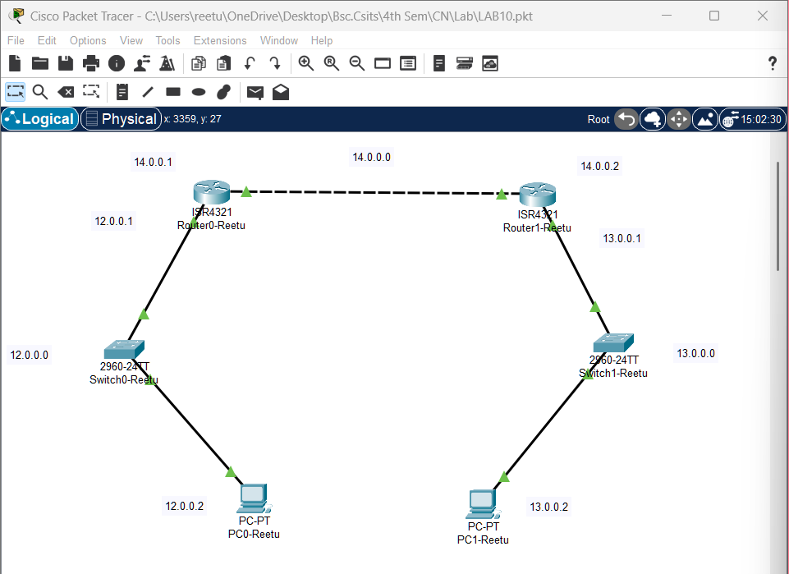

Fig: Network Diagram

**Code for Dynamic Routing Configuration using RIP command**

**For Router 0**

Router>enable

Router#configure terminal

Router(config)#router rip

Router(config-router)#version 2

Router(config-router)#network 10.0.0.0

Router(config-router)#network 12.0.0.0

Router(config-router)#exit

**For Router 1**

Router>enable

Router#configure terminal

Router(config)#router rip

Router(config-router)#version 2

Router(config-router)#network 12.0.0.0

Router(config-router)#network 11.0.0.0

Router(config-router)#exit

**Steps for Dynamic Routing Configuration using RIP Command**

**Step 1: Access the Router CLI**

Open Packet Tracer

Click on the router we want to configure to access its CLI (Command Line Interface).

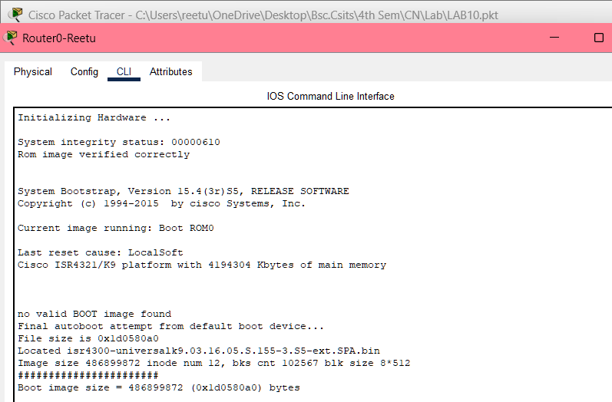

Fig: Accessing Router CLI via Console Cable

**Step 2: Enter Global Configuration Mode**

Enable RIP Routing Protocol

Specify the RIP Version

Configure the RIP Networks

Exit RIP Configuration Mode

Fig: Router configuration of router0 and router1 using RIP command

**Testing**

To test whether the network is working, we can ping other devices on the network from each PC. If the ping is successful, we should see replies from the other device.

Fig: Connectivity test from PC0-Reetu to PC1-Reetu

Fig: Connectivity test between PC1-Reetu to PC0-Reetu

Above figure shows the results of a ping test between two PCs on a network. The ping test was successful, indicating that there is connectivity between the two devices. The output of the ping test shows the number of packets sent, received, and lost, as well as the approximate round trip time for each packet.

**Using OSPF Command**

**Network Diagram**

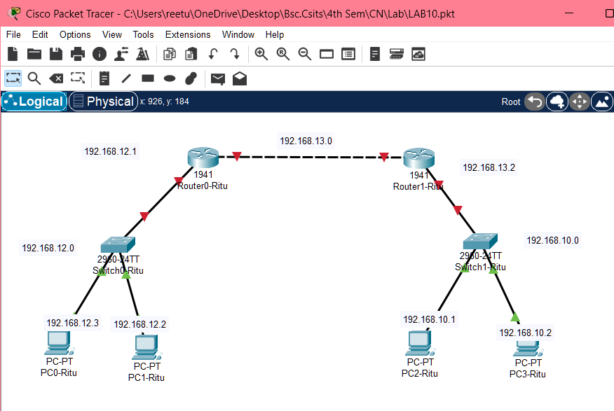

Fig: Network Diagram

**Code for Dynamic Routing Configuration Using OSPF Command**

**For Router0**

Router>enable

Router#config t

Router(config)#router ospf 1

Router(config-router)#network 192.168.10.0 0.0.0.255 area 0

Router(config-router)#network 192.168.13.0 0.0.0.255 area 0

Router(config-router)#exit

**For Router1**

Router>enable

Router#config t

Router(config)#router ospf 2

Router(config-router)#network 192.168.12.0 0.0.0.255 area 0

Router(config-router)#network 192.168.13.0 0.0.0.255 area 0

Router(config-router)#exit

**Steps for Dynamic Routing Configuration using OSPF command**

**Step 1: Access the Router CLI**

Open Packet Tracer.

Click on the router we want to configure to access its CLI (Command Line Interface).

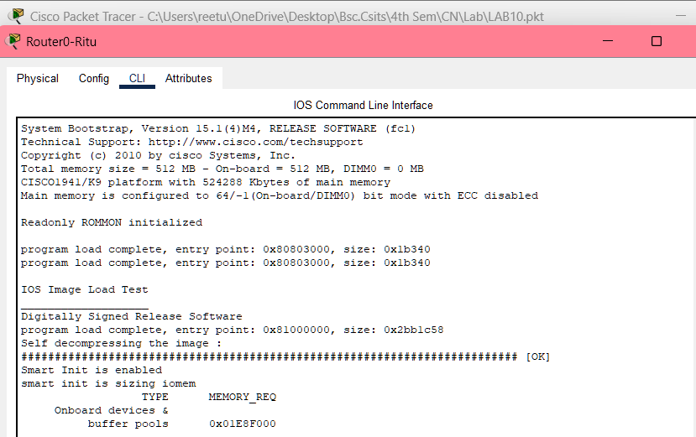

Fig: Accessing Router Command-Line Interface via Console Cable

**Step 2: Enter Global Configuration Mode**

Enable OSPF Routing Protocol

Start the OSPF process and assign it a process ID

Assign a router ID

Specify the networks connected to Router 1, and define the areas.

Exit OSPF configuration.

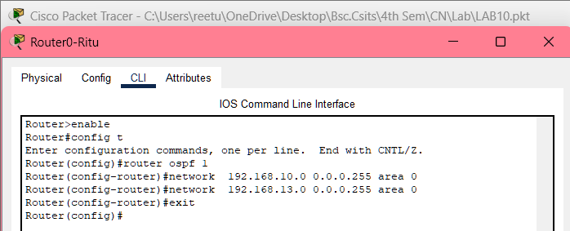

Fig: Router configuration for router0 and router1 using OSPF command

**Testing**

To test whether the network is working, we can ping other devices on the network from each PC. If the ping is successful, we should see replies from the other device.

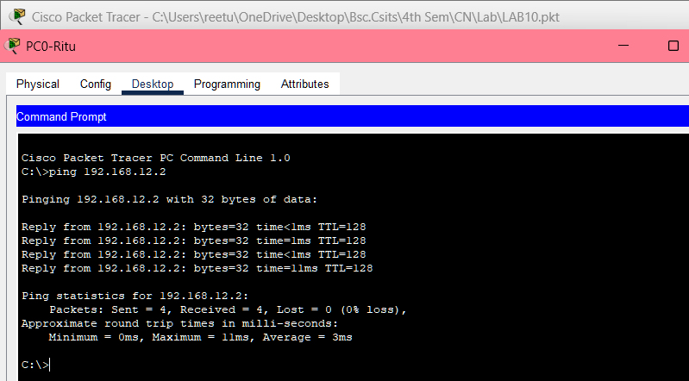

Fig: Connectivity test from PC0-Ritu to PC1-Ritu

Fig: Connectivity test from PC1-Ritu to PC0-Ritu

Above figure shows the results of a ping test between two PCs on a network. The ping test was successful, indicating that there is connectivity between the two devices. The ping output of the ping test shows the number of packets sent, received, and lost, as well as the approximate round trip time for each packet.

**Addressing Table:**

The addressing table of the OSPF configuration is as follows:

|  |  |  |  |  |
| --- | --- | --- | --- | --- |
| Device | Interface | IPv4 Address | Subset | Router no. |
| PC0 | NIC | 192.168.12.3 | 255.255.255.0 | 0 |
| PC1 | NIC | 192.168.12.2 | 255.255.255.0 | 0 |
| PC2 | NIC | 192.168.10.1 | 255.255.255.0 | 1 |
| PC3 | NIC | 192.168.10.2 | 255.255.255.0 | 1 |

**Using BGP Command**

**Network Diagram**

Fig: Network Diagram

**Code for Dynamic Routing Configuration Using BGP Command**

**For Router 0**

Router0> enable

Router0# configure terminal

Router(config)# router bgp 100

Router(config-router)# network 195.168.1.0

Router(config-router)# network 195.168.2.0

Router(config-router)# neighbor 195.168.2.2 remote-as 200

Router(config-router)# neighbor 195.168.3.2 remote-as 200

Router(config-router)# exit

**For Router1**

Router0> enable

Router0# configure terminal

Router(config)# router bgp 200

Router(config-router)# network 195.168.2.0

Router(config-router)# network 195.168.3.0

Router(config-router)# neighbor 195.168.2.1 remote-as 100

Router(config-router)# neighbor 195.168.1.2 remote-as 100

Router(config-router)# exit

**Steps For Dynamic Routing Configuration Using BGP Command**

**Step 1: Access the Router CLI**

Open Packet Tracer

Click on the router we want to configure to access its CLI (Command Line Interface).

.

Fig: Accessing Router CLI via Console Cable

**Step 2: Enter Global Configuration Mode**

Enable BGP Routing Protocol

Start the BGP process and specify the AS number

Configure Neighbor

Advertise Networks

Exit BGP configuration

Fig: Router configuration for router0 and router1 using BGP command

**Testing**

To test whether the network is working, we can ping other devices on the network from each PC. If the ping is successful, we should see replies from the other device.

Fig: Connectivity test from Reetu-PC0 to Reetu-PC1

Fig: Connectivity test from Reetu-PC1 to Reetu-PC0

Above figure shows the results of a ping test between two PCs on a network. The ping test was successful, indicating that there is connectivity between the two devices. The output of the ping test shows the number of packets sent, received, and lost, as well as the approximate round trip time for each packet.

**Addressing Table:**

The addressing table of the BGP Configuration is as follows:

|  |  |  |  |  |  |
| --- | --- | --- | --- | --- | --- |
| Device | Interface | IPv4 Address | Subnet | Router No. | Link |
| Reetu-PC0 | NIC | 195.168.1.2 | 255.255.255.0 | 0 | Access |
| Reetu-PC1 | NIC | 195.168.3.2 | 255.255.255.0 | 1 | Access |

**Conclusion**

In this lab, we implemented dynamic routing protocols RIP, OSPF and BGP to automate route updates and maintain efficient network connectivity. RIP’s simplicity makes it suitable for smaller networks, while OSPF’s faster convergence and scalability handle larger, more complex networks effectively. BGP plays a crucial role in exterior routing, managing inter-AS communication and supporting global internet traffic. Through successful ping tests, we verified proper network configuration and confirmed the seamless operation of these protocols.